**Master Functional Document**

|  |  |
| --- | --- |
| **Application** | NGERP - Centra |
| **Service Bundle** | Master Management |
| **Service Request** | Session Audit |

**Description :**

Session Audit Master is Used to monitor the login activity of the user.

**Workflow Process :**

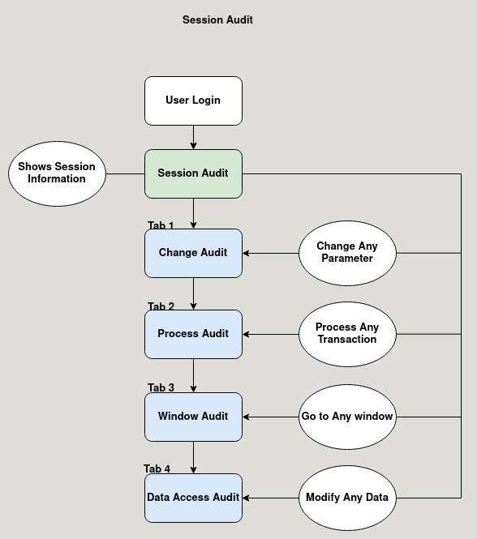

**Business Rules :**

* Session Audit Master is Used to monitor the login activity of the user.
* It show the information like who logged in, when they logged in, their IP Address, session ID and how much time they have spent in the application on that session.
* There are four tabs in the session audit Master:
  + Change Audit
  + Process Audit
  + Window Audit
  + Data Access Audit
* **Change Audit:**

This Tab Logs the Changes made in any parameter by showing old value and new value.

* **Process Audit:**

This Tab Logs all the Transaction made by that user.

* **Window Audit:**

This Tab Logs all the window the user have visited.

* **Data Access Audit:**

This Tab Logs the Modification in any parameters.